Fourth Class List

Stationary
- 2 x 2B pencils
- Red pen
- Eraser
- Pencil Sharpener
- 30cm Ruler
- Pack of colouring pencils
- 2 x Whiteboard markers with erasers
- Pencil case
- Glue stick

* Please label all stationary clearly.

Copies
- 2 x 40 Page Sum Copies (1 cm square)
- 6 x 40 Page Regular Copies (English, 2 x Homework copy, Gaeilge, Religion, Spare)
- 1 x A4 copy
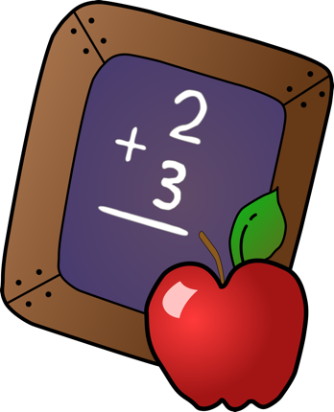
- 1 x Handwriting Copy
- 3 x Button down plastic folders (One homework folder and 2 for the classroom)
- 2 x small notebooks (Spelling and vocabulary)
- 1 x school journal (Available in office in September)

* Please have child’s name on all copies and folders. Please cover copies with plastic covers so they can be easily wiped clean.

