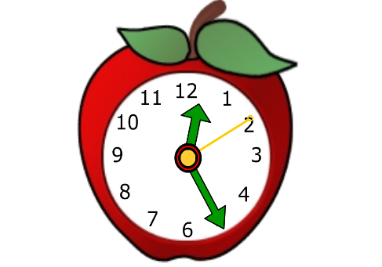
5th Class

Miss Cukur and Miss O’ Sullivan
2021-2022

4 x 88 page copies
1 x 88 page maths copy
1 B4 handwriting copy
2 manuscript copies
2 small notebooks
1 hardback folder with poly pockets
1 plastic button folder
1 St Catherine’s homework journal (available in Sept. in school)

All copies must be covered with wipeable plastic covers. Copies will be labelled in class in Sept.

You also need:
- Pencil-case (plastic, wipeable)
- 1 whiteboard marker
- 2 pencils
- An eraser
- A parer
- A red biro
- A 30cm ruler
- A maths set
- Colours
- Pritt stick
- Runners for P.E.
- A small wash bag

I am looking forward to seeing you all soon!

